**-: DevOPs Introduction :-**

**DevOps Architectural Block Diagram :**

In this training we will learn about DevOps with Amazon Web Services (AWS). Concepts and Tools that will be covered in this training are : Linux OS & Shell scripting basics, Git, Jenkins, Docker, AWS ( EC2, S3, IAM), JIRA.

The word “DevOps” was coined in 2009 by Patrick Debois.

A compound of development (Dev) and operations (Ops), DevOps is the union of people, process, and technology to continually provide value to customers.

DevOps enables formerly siloed roles—development, IT operations, quality engineering, and security—to coordinate and collaborate to produce better, more reliable products. By adopting a DevOps culture along with DevOps practices and tools, teams gain the ability to better respond to customer needs, increase confidence in the applications they build, and achieve business goals faster.

*The two primary antecedents of DevOps are:*

1. Enterprise systems management (ESM) : Admins
2. Agile development : Developers (Code & Automation)

a DevOps engineer is needs to have an understanding of SDLC (Software Development Lifecycle) and of automation tools for developing CI/CD pipelines.

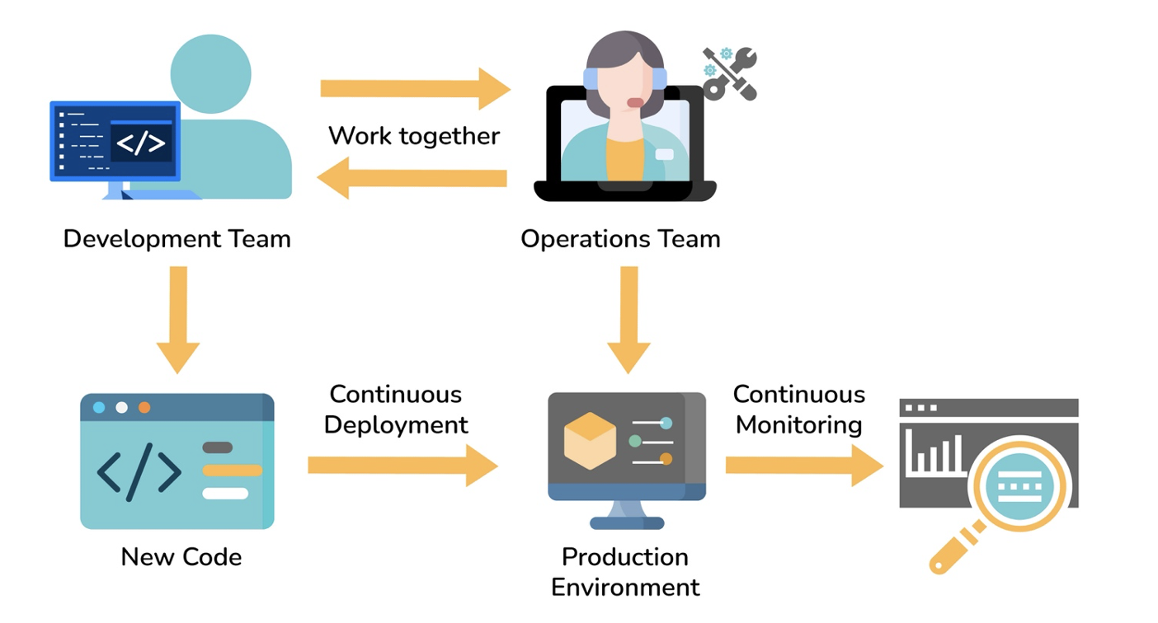

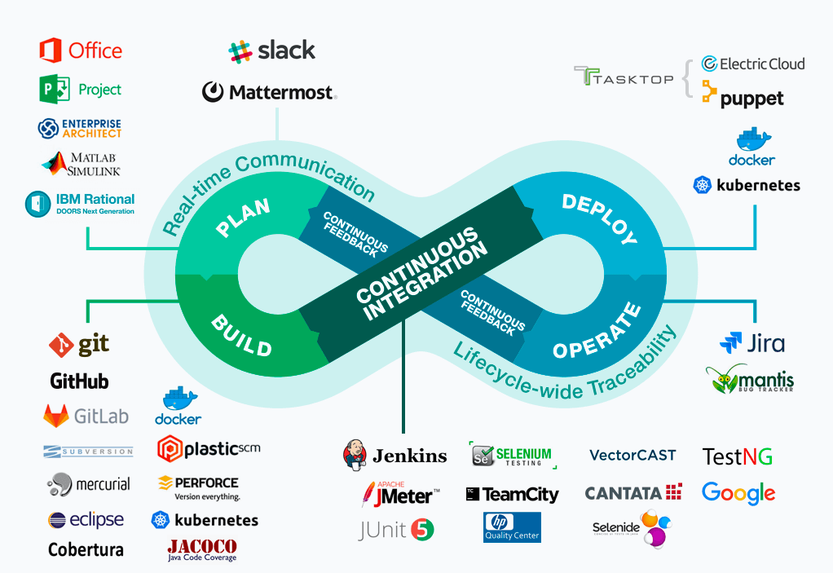

**DevOPs Practices**

1. Collaboration between teams
2. Continuous integration and continuous delivery/deployment (CI/CD)
3. Version control
4. Infrastructure as code
5. Configuration management
6. Continuous Testing and monitoring

**The Benefits of DevOPs**

* Accelerating time to market due to reduced release cycle
* Adapting to the market and competition
* Maintaining system stability and reliability
* More focus on innovation
* Early error detection – Shift left
* Improving customer experience

**DevOps Future Trends:**

Microservices architecture, DevSecOps, AI and ML Integration, Serverless architecture, IaC adoption.

**Build & Release process**

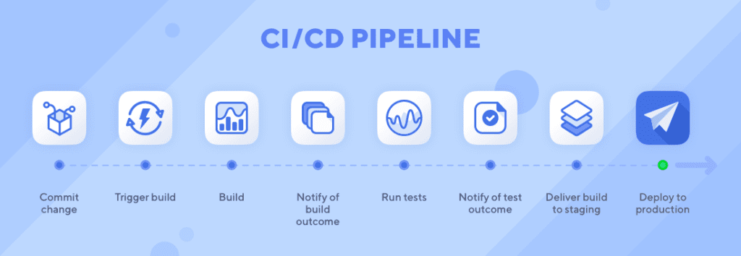

*“DevOps is not a goal, but a never-ending process of continuous improvement.”*

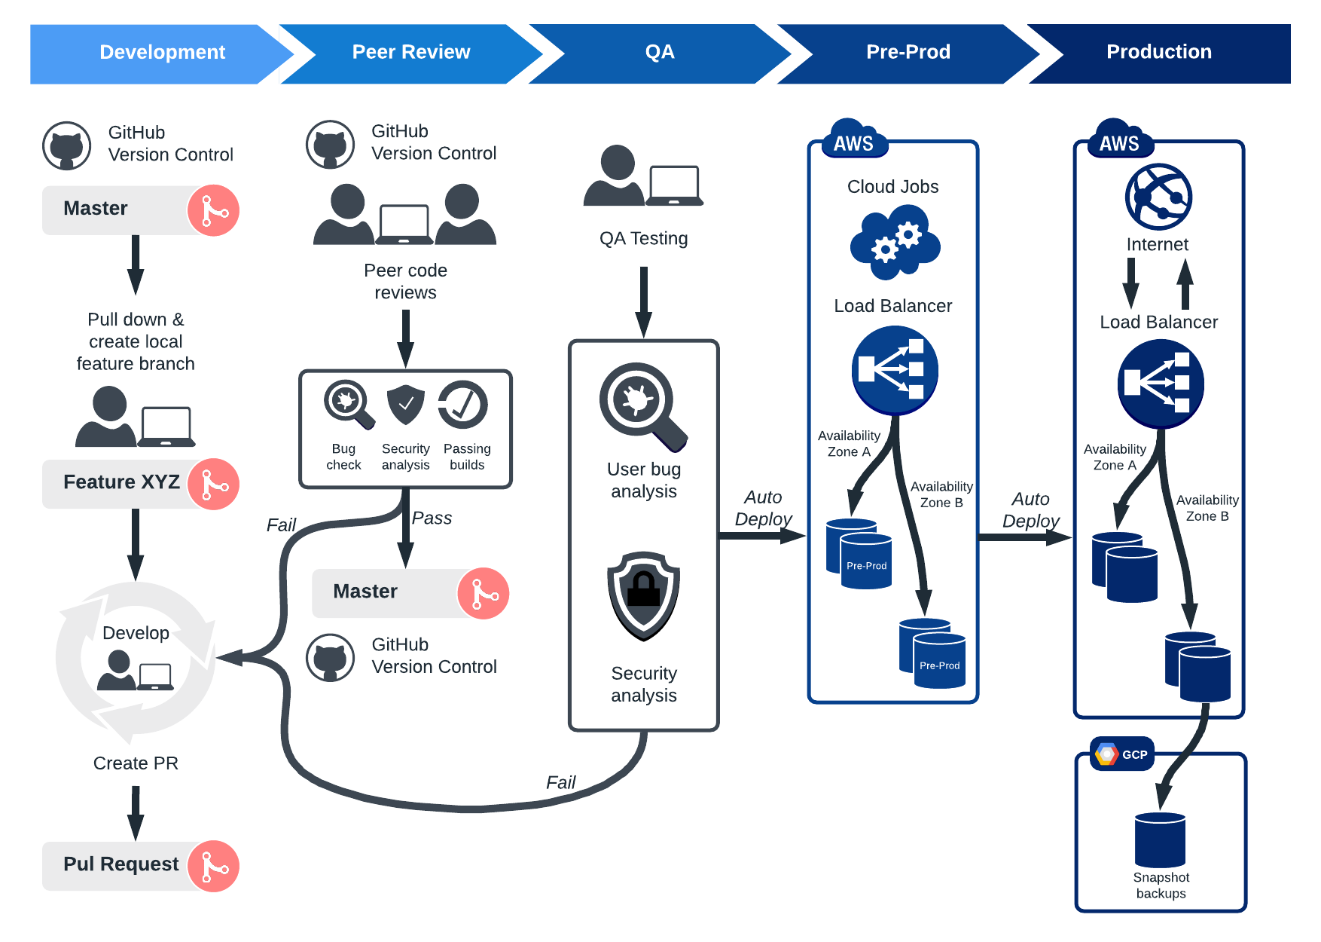

**SDLC – Software Development Life Cycle**

The **Software Product Development Life Cycle** is a framework that aligns and streamlines tasks at each phase of software development.

The purpose of adherence to the SDLC methodology is to organize product development systematically and in a disciplined way. The SDLC phases cover the complete development cycle from ideation to launch and maintenance.

Software product requirements differ based on the product’s nature, the software development life cycle has several models. However, each model has its unique features and comes with its own benefits and drawbacks.

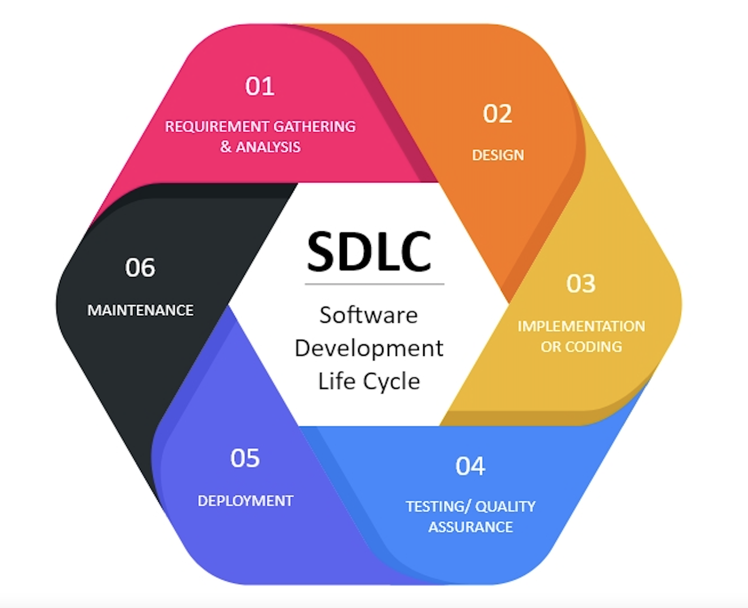

**SDLC Models:**

1. Waterfall model
2. V-Shaped model
3. Prototype
4. Spiral
5. Agile

**AWS Technology Stack for CI CD**

**Code Commit** can be used as a private code repository for version control for collaboration, backup and audit. It includes all the benefits of AWS i.e., Scale, Security, Compliance and integration with other services including AWS Code Build, Jenkins etc. You can use GIT to integrate your local repository with the Code Commit repository. You can configure role-based access, notifications and triggers. For e.g. You can configure a trigger to execute a lambda function for automation.

**Code Build** A fully managed build service can be an alternative to tools like Jenkins. It has all the benefits of a managed service i.e., scale, security and no maintenance overhead and power of integration with services like Cloud Watch for notifications & alerts and Lambda for automation. It uses Docker containers under the hood (you can use your own docker image as well), is serverless and pure Pay as You Go (PAYG).

**Code Deploy** managed service by AWS is to deploy code on EC2 instances or on-premises machines. Code deploy can be used instead of tools like terraform, ansible etc. if it meets your requirement of continuous deployment. You can group the environment such as prod, dev etc. Code deploy will not provide resources for you. Code deploy agent will be running on the server/EC2 instance and will perform the deployment.

**Code Pipeline** to orchestrate the whole deployment. It supports code repositories such as GitHub, Code Commit, build tools such as Code Build, Jenkins, deployment tools such as Code Deploy, Terraform, and load testing tools. It creates artefacts for each stage.

All these services can easily use powerful management and monitoring tools like CloudWatch for logging and monitoring.